**Questions on Location Management**

1. Explain the two processes in location management.

Location management is a two-stage process: the first stage is to discover the current attachment point of the mobile user for call delivery and the second one is call delivery.

1. Relate the concept of La and PA.

For LM purposes, a wireless network usually consists of Location Areas (LAs) and Paging Areas (PAs). While LAs are a set of areas over which location updates take place, PAs are a set of areas over which paging updates take place. Usually, LAs and PAs are contiguous, but that's not the case always. In addition, a LA usually contains several PAs.

1. Explain the static LU schemes with limitations.

Three simple static Location Update schemes exist in static LM, being always-update, never-update, and static interval-based. The third of these is the most commonly used in practical static LM systems.  
  
One scheme involves the user updating its location upon every inter-cell movement, and is named always-update. This will incur significant energy and computational costs to both the network and the user, especially to the most mobile users. This may be particularly wasteful, as if a user makes frequent, quick movements within an LA, beginning and ending at the same location, many LUs will occur that might be unnecessary, especially if few or no calls are incoming. However, the network will always be able to quickly locate a user upon an incoming call, and extensive paging will not be necessary.  
  
The converse method would be to never require the user to inform the network of intercell movements, only updating on LA changes, and is named never-update. In this scheme, resources are saved as constant updates are not required, but paging costs rise substantially. This occurs as every cell within the user’s LA may need to be checked during paging due to the lack of information, which causes excessive overhead for users with a high incoming call frequency.  
  
These two schemes are generally unused in real-world systems, but help to provide an illustration to network administrators as to the costs of LM, the problems that occur when thoughtless LU methods are used, and a baseline that every newly developed LU scheme must show improvements over.  
  
The final static LM technique discussed requires each user within the network to update at static, uniform intervals. This attempts to provide a balance between the extremes of the previous schemes, as the network will neither be overwhelmed with LUs nor wholly unaware of users’ locations. However, users with rapid rates of movement may move into new LAs between updates, which causes locating that user to be very difficult. Conversely, an inactive user will not move at all, but will still regularly be sending unneeded LUs.

1. What are the issues in LM.

Current issues for LM involve

1. database architecture design,
2. transmission of signaling between various components of a signaling network,
3. security,
4. dynamic database updates,
5. querying delays,
6. terminal paging methods
7. paging delays.
8. What are LM schemes

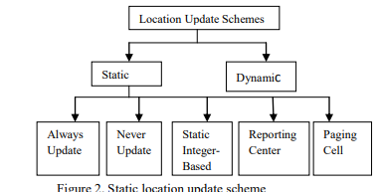

1. Explain the call process in two level hierarchical database system in cellular communication.

1. What are LM parameters explain.

### Paging

In the attempt to locate recipients of calls as quickly as possible, multiple methods of paging have been created. The most basic method used is Simultaneous Paging, where every cell in the user’s LA is paged at the same time in order to find the user. Unless there are a relatively low number of cells within the LA, this will cause excessive amounts of paging. Although this method will find the user quicker than the following scheme of Sequential Paging, the costs make Simultaneous Paging rather inefficient.

### User Mobility

For aid in effectively predicting the user’s next location, user movement patterns are analyzed and mobility models are designed. Many such mobility models exist and can be used by networks in LM. The simplest of these models is random-walk, where user movements are assumed to be entirely random. While this is clearly going to lead to inaccurate predictions, it does require no knowledge of the individual user, and can be effective as a simulation tool. Frequently, random-walk is used to demonstrate the improvements a given scheme makes in comparison to this random method.

1. Explain indoor mobility models for individual node movement.
2. What are the advantages of group based mobility models.

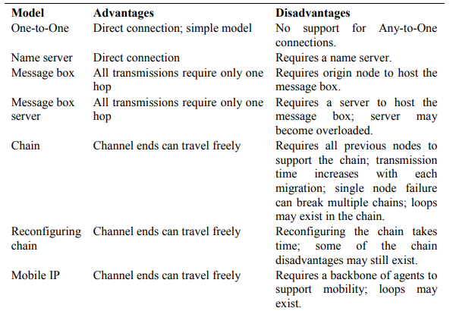

1. Explain dynamic LU schemes.

# Threshold-based

**Time-based Update** The time-based strategy requires that users update their location at constant time intervals. This time interval may then be optimised per-user, to minimise the number of redundant update messages sent. This only requires the mobile device to maintain a simple timer, allowing efficient implementation and low computational overhead.

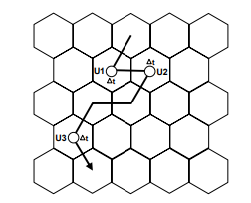

**Movement-based Update** The movement-based update scheme requires mobile devices to update their location after a given number of boundary-crossings to other cells in the network. This boundary-crossing threshold may be assigned per-user, optimised for individual movement and call arrival rates

**Distance-based Update** In a distance-based scheme the mobile device performs a location update when it has moved a certain distance from the cell where it last updated its location. Again, this distance threshold may be optimised per-user according to movement and call-arrival rates.

# Profile-based

Under a profile-based scheme the network maintains a profile for each user in the network, based on previous movements, containing a list of the most probable cells for the user to reside within.

# Adaptive

The group of adaptive location update schemes comprises a large number of current developments in location management. Adaptive schemes take into consideration a variety of user parameters when assigning a location area to a mobile device.

1. Explain different paging techniques.

# Simultaneous Paging

The simultaneous paging scheme, also known as blanket paging, is the mechanism used in current GSM network implementations. Here all cells in the users location area are paged simultaneously, to determine the location of the mobile device. This requires no additional knowledge of user location but may generate excessive amounts of paging traffic.

# Sequential Paging

Sequential paging avoids paging every cell within a location area by segmenting it into a number of paging areas, to be polled one-by-one.

# Intelligent Paging

The intelligent paging scheme is a variation of sequential paging, where the paging order is calculated probabilistically based on pre-established probability metrics.

1. What is handoff and illustrate the scenarios of handoff.

The process of transferring an in-progress call from one cell or base station to a neighbouring cell without interruption.

* + - 1. For every handoff to a neighbour cell, increment the handoff tally for that particular neighbour, or record the cell as a neighbour if not previously seen
      2. On a cell refresh, divide each individual handoff tally by the total number of handoffs to obtain the probability of moving to each cell in the last handoff interval
      3. Update the stored movement probability to each cell, smoothing the values using a simple exponentially weighted moving average
      4. Normalise the total probabilities of moving to each cell to ensure they sum to 1.0
      5. Reset each handoff tally to zero and continue the process

1. Explain different types of handoff?

Hard Handoff: Characterized by an actual break in the connection while switching from one cell or base station to another. The switch takes place so quickly that it can hardly be noticed by the user. Because only one channel is needed to serve a system designed for hard handoffs, it is the more affordable option. It is also sufficient for services that can allow slight delays, such as mobile broadband Internet.

Soft Handoff: Entails two connections to the cell phone from two different base stations. This ensures that no break ensues during the handoff. Naturally, it is more costly than a hard handoff.

1. Explain group based mobility models.

The group mobility model we proposed here is called Reference Point Group Mobility (RPGM) model. Each group has a logical “center”. The center’s motion defines the entire group’s motion behavior, including location, speed, direction, acceleration, etc. Thus, the group trajectory is determined by providing a path for the center. Usually, nodes are uniformly distributed within the geographic scope of a group. To node, each is assigned a reference point which follows the group movement. A node is randomly placed in the neighborhood of its reference point at each step. The reference point scheme allows independent random motion behavior for each node, in addition to the group motion.

1. How is movement based LU different from distance based LU.

The movement-based update scheme requires mobile devices to update their location after a given number of boundary-crossings to other cells in the network. This boundary-crossing threshold may be assigned per-user, optimised for individual movement and call arrival rates

In a distance-based scheme the mobile device performs a location update when it has moved a certain distance from the cell where it last updated its location. Again, this distance threshold may be optimised per-user according to movement and call arrival rates.

